Day 6:

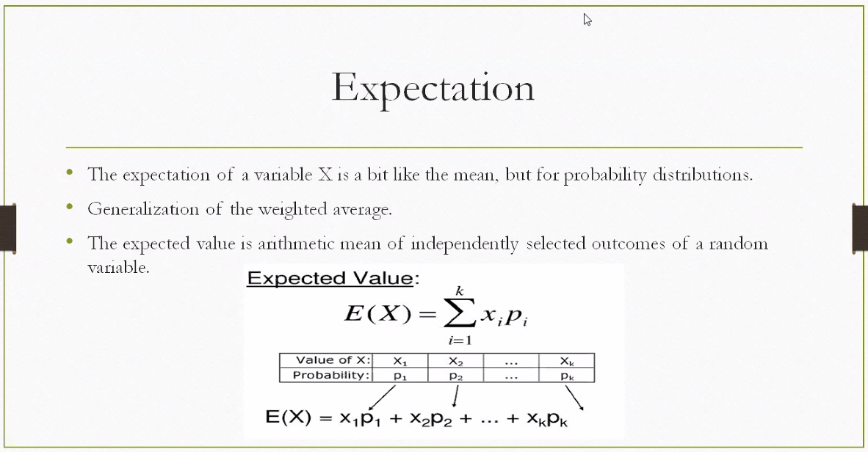

🎯 What is Expectation?
- It’s the average outcome you'd expect if you repeated a random experiment many times.
- Think of it as the center of gravity of a probability distribution — like a weighted mean.
📊 Formula Breakdown
The formula shown is:
$$E(X)=\sum_{i=1}^{k}{}x_{i}p_{i}=x_{1}p_{1}+x_{2}p_{2}+…+x_{k}p_{k}$$
Where:
- $x_{i}$= possible values of the random variable $X$
- $p_{i}$= probability of each value $x_{i}$
- $k$= total number of possible outcomes
This is a weighted average, where each value is multiplied by how likely it is.
🧠 Intuition with Example
Imagine a game where:
- You win ₹10 with probability 0.2
- ₹50 with probability 0.3
- ₹100 with probability 0.5
Then the expected winnings are:
$$E(X)=10(0.2)+50(0.3)+100(0.5)=2+15+50=\text{₹}67$$
So, on average, you'd expect to win ₹67 per game in the long run.
🔁 Why It Matters
- In decision-making: Helps evaluate long-term outcomes.
- In statistics: Forms the basis for variance, standard deviation, and more.
- In machine learning: Used in loss functions and probabilistic models.

Random Variable: It is any random value that has probability attached to it.

What is difference between Frequency distribution and probability distribution
Frequency distribution shows how often outcomes occurred in actual data; probability distribution shows how likely outcomes are in theory.
🔍 Key Differences Between Frequency and Probability Distributions
Feature | Frequency Distribution | Probability Distribution
Definition | Tabulates how often each value appears in a dataset | Describes the likelihood of each possible value of a random variable
Basis | Based on observed data (empirical) | Based on theoretical models or assumptions
Values | Frequencies or relative frequencies | Probabilities (between 0 and 1, summing to 1)
Purpose | Summarizes actual data | Models uncertainty and predicts outcomes
Example | Survey shows 30 people chose option A, 20 chose B | A fair die has probability 1/6 for each face
Use Case | Data analysis, histograms, descriptive stats | Statistical modeling, simulations, inferential stats
🧠 Intuition
- Frequency distribution is what happened.
  - E.g., You toss a coin 100 times and get 55 heads → frequency of heads = 55.
- Probability distribution is what you expect.
  - E.g., For a fair coin, probability of heads = 0.5.
As sample size increases, relative frequencies tend to converge to probabilities — this is the Law of Large Numbers.
📌 Example Comparison
Suppose you roll a die 60 times and record outcomes:
Outcome | Frequency | Relative Frequency | Probability (Theoretical)
1 | 8 | 8/60 = 0.133 | 1/6 ≈ 0.167
2 | 10 | 0.167 | 0.167
3 | 12 | 0.200 | 0.167
4 | 9 | 0.150 | 0.167
5 | 11 | 0.183 | 0.167
6 | 10 | 0.167 | 0.167
Here, the frequency distribution is based on actual rolls, while the probability distribution assumes a fair die.

Here’s another clear example of a probability distribution in tabular format — this time for a fair six-sided die:
🎲 Probability Distribution: Rolling a Fair Die
Outcome (X) | Probability $P(X)$
1 | $$\frac{1}{6}≈0.167$$
2 | $$\frac{1}{6}≈0.167$$
3 | $$\frac{1}{6}≈0.167$$
4 | $$\frac{1}{6}≈0.167$$
5 | $$\frac{1}{6}≈0.167$$
6 | $$\frac{1}{6}≈0.167$$
- Total probability: $∑P(X)=1$
- Expected value:
$$E(X)=∑x_{i}p_{i}=1⋅\frac{1}{6}+2⋅\frac{1}{6}+…+6⋅\frac{1}{6}=\frac{21}{6}=3.5$$
This shows that if you roll a fair die many times, the average outcome tends toward 3.5, even though 3.5 is not a possible roll.

What is of slot machine game, please explain me
A slot machine is a gambling game where players spin reels with symbols, and win if certain symbol combinations align according to the machine’s paytable.
🎰 How Slot Machines Work
- Structure: A slot machine has reels (traditionally 3 or 5) with various symbols. When you press “spin,” the reels stop at random positions.
- Randomness: Modern slots use a Random Number Generator (RNG) to ensure fairness. Each spin is independent — past results don’t affect future ones.
- Winning: If the reels stop in a way that matches a winning combination (like three identical symbols in a row), you win. The payout depends on the rarity of the symbols and the rules in the paytable.
- Betting: Players choose how much to bet per spin. Larger bets can unlock more paylines (ways to win).
- RTP & Volatility:
  - RTP (Return to Player): The long-term percentage of money wagered that the machine pays back (e.g., 95%).
  - Volatility: Describes risk level — high volatility means rare but big wins; low volatility means frequent but smaller wins.

🧩 Example
Suppose a simple slot has 3 reels and symbols 🍒, 🍋, and ⭐.
- Probability of getting 🍒🍒🍒 might be 1 in 100 spins.
- If that happens, the payout could be 50× your bet.
- More common combinations (like 🍒🍋⭐) might pay nothing.

Slot machine Example :
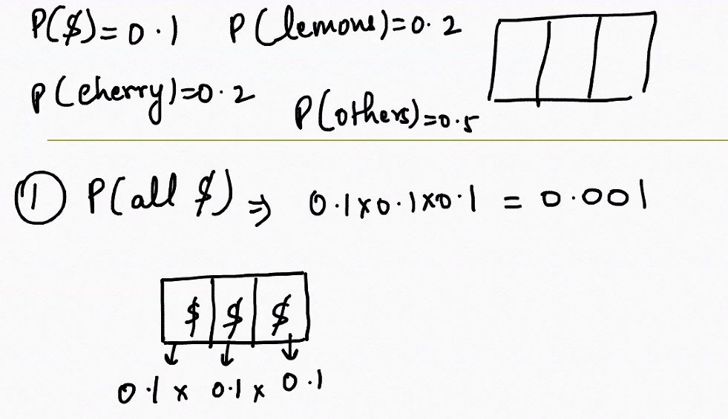
🎰 Slot Machine Setup
Each reel (there are 3) can show one of the following symbols:
Symbol | Probability
$ | 0.1
🍋 Lemon | 0.2
🍒 Cherry | 0.2
Others | 0.5
Each reel spins independently, so the total probability of a combination is the product of individual probabilities.
🧮 Example: Probability of All $ Symbols
To get $ on all three reels:
$$P(\text{All }\$)=P(\$)⋅P(\$)⋅P(\$)=0.1⋅0.1⋅0.1=0.001$$
So, the chance of hitting three dollar signs is just 0.1% — very rare!
📊 Probability Distribution (Simplified)
Here’s a sample distribution for some outcomes:
Combination | Probability
$ $ $ | 0.001
🍒 🍒 🍒 | $${0.2}^{3}=0.008$$
🍋 🍋 🍋 | $${0.2}^{3}=0.008$$
Others Others Others | $${0.5}^{3}=0.125$$
Each combination has its own probability, and the payouts are usually higher for rarer combinations.
🎯 Why This Matters
- Slot machines use probability distributions to balance payouts vs. profits.
- The expected value of a spin can be calculated using:
$$E(X)=∑(\text{payout}×\text{probability})$$
- Casinos design games so that $E(X)$is less than your bet, ensuring long-term profit.

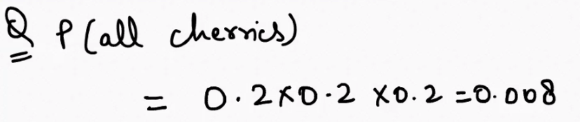
🎯 1. Probability of All Cherries
You’re calculating the chance that all three reels show a 🍒 cherry.
- Given: $P(\text{cherry})=0.2$on each reel
- Since each reel is independent:
$$P(\text{all cherries})=0.2⋅0.2⋅0.2=0.008$$
✅ So, the chance of hitting 🍒🍒🍒 is 0.8% — quite rare!

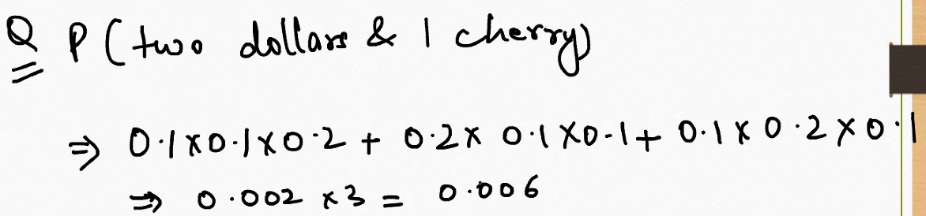

🎯 2. Probability of Two Dollars and One Cherry
Now we want the probability of getting exactly two $ symbols and one 🍒 cherry, in any order.
Step-by-step:
- $P(\$)=0.1$, $P(\text{cherry})=0.2$
- There are 3 possible arrangements:
  - $ $ 🍒
  - $ 🍒 $
  - 🍒 $ $
Each arrangement has the same probability:
$$P(\$\$\text{🍒})=0.1⋅0.1⋅0.2=0.002$$
Multiply by the number of arrangements:
$$P(\text{2 \$ and 1 }\text{🍒})=3⋅0.002=0.006$$
✅ So, the chance of getting two dollars and one cherry is 0.6%.

🧠 Why This Matters
These calculations show how slot machines balance rare outcomes with big payouts. The rarer the combination, the higher the reward — but the lower the probability.

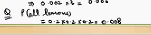
🍋 Given Probabilities
Each reel has these symbol probabilities:
Symbol | Probability
$ | 0.1
🍋 Lemon | 0.2
🍒 Cherry | 0.2
Others | 0.5
🎯 Goal: Probability of All Lemons
We want the probability that each of the 3 reels shows a lemon.
Since each reel is independent:
$$P(\text{All lemons})=P(\text{lemon})⋅P(\text{lemon})⋅P(\text{lemon})=0.2⋅0.2⋅0.2=0.008$$
✅ So, the chance of hitting 🍋🍋🍋 is 0.8%.
🧠 Interpretation
- This is a rare event, just like getting all cherries or all dollar signs.
- In slot machines, such rare combinations often trigger higher payouts.
- The probability is low because each lemon has only a 20% chance per reel, and we need all three to align.

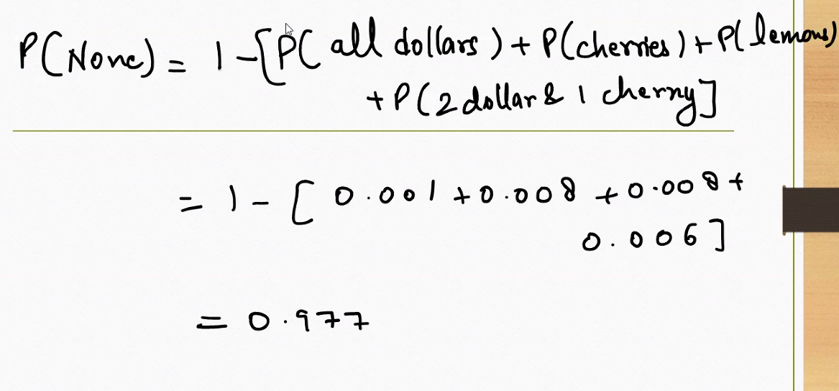
You're working through a great example of complement probability — calculating the chance of getting a “non-winning” outcome on a slot machine by subtracting the probabilities of all winning outcomes from 1.
🎰 Problem Setup
You’re given probabilities for specific winning combinations:
Winning Outcome | Probability
All $ symbols | 0.001
All 🍒 cherries | 0.008
All 🍋 lemons | 0.008
Two $ and one 🍒 cherry | 0.006
These are mutually exclusive — they can't happen at the same time.
🧮 Step-by-Step Calculation
You want to find the probability of “None” — meaning none of these winning combinations occur.
Use the complement rule:
$$P(\text{None})=1-P(\text{Any winning outcome})$$
$$P(\text{None})=1-(0.001+0.008+0.008+0.006)=1-0.023=0.977$$
✅ So, the chance of getting a non-winning spin is 97.7%.
🧠 Why This Matters
- This shows how rare winning combinations are in slot machines.
- It also helps calculate expected losses — most spins don’t win.
- You can use this to build a full expected value model for the game.

How much money is a person going to gain on average in a game:
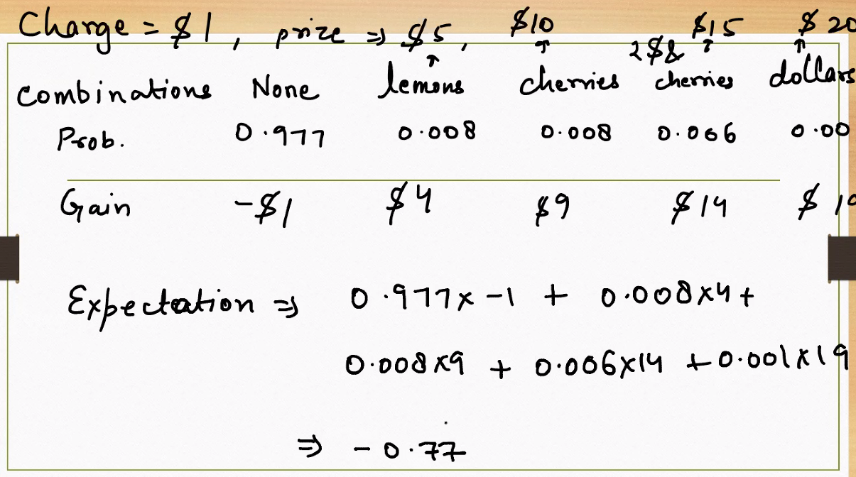

You're now working with a full expectation calculation for a slot machine game — combining probabilities and payouts to find the average gain or loss per play. Let’s break it down step by step.
🎰 Game Setup
- Cost to play: $1
- Possible prizes: $5, $10, $15, $20
- Net gain = prize − cost to play
📊 Table Breakdown
Combination | Probability | Net Gain
None (no win) | 0.977 | −$1
Lemons (🍋🍋🍋) | 0.008 | $4
Cherries (🍒🍒🍒) | 0.008 | $9
2 cherries + 1 🍒 | 0.006 | $14
All dollars ($$$) | 0.001 | $19
🧮 Expected Value Calculation
$$E(X)=0.977⋅(-1)+0.008⋅4+0.008⋅9+0.006⋅14+0.001⋅19$$
Break it down:
- $0.977⋅(-1)=-0.977$
- $0.008⋅4=0.032$
- $0.008⋅9=0.072$
- $0.006⋅14=0.084$
- $0.001⋅19=0.019$
Add them up:
$$E(X)=-0.977+0.032+0.072+0.084+0.019=-0.77$$
📉 Interpretation
- Expected gain per play: −$0.77
- That means on average, a player loses 77 cents per spin.
- This is how casinos ensure profit — the game is designed so the expected value is negative for the player.

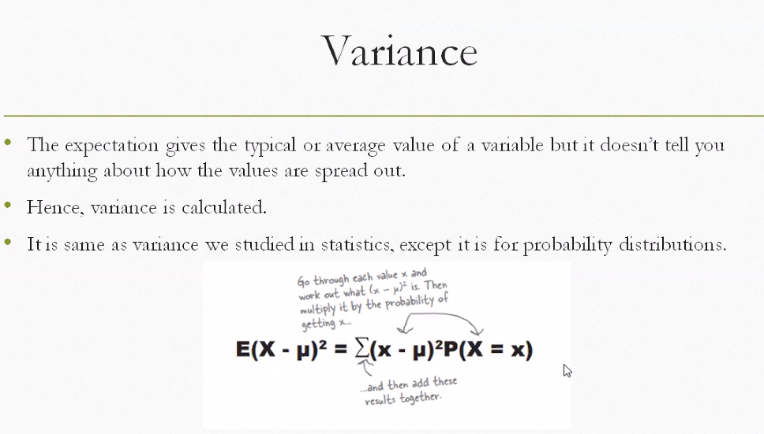
You're now exploring variance in the context of probability distributions — a key concept that tells us how spread out the values of a random variable are around the expected value (mean).
📌 Why Variance Matters
- Expectation (mean) tells us the average value.
- Variance tells us how much the values deviate from that average.
- A low variance means values are tightly clustered around the mean.
- A high variance means values are more spread out.
📊 Variance Formula
$$\text{Var}(X)=E[(X-μ)^{2}]=∑(x-μ)^{2}⋅P(X=x)$$
Where:
- $X$is a random variable
- $μ=E(X)$is the expected value
- $P(X=x)$is the probability of each value $x$
🧠 Step-by-Step Intuition
- Find the mean $μ=E(X)$
- For each value $x$:
  - Compute the deviation: $x-μ$
  - Square it: $(x-μ)^{2}$
  - Multiply by the probability: $(x-μ)^{2}⋅P(X=x)$
- Add up all those weighted squared deviations
This gives you the average squared deviation from the mean — the variance.
🎯 Example
Suppose a random variable $X$has:
Value $x$ | Probability $P(X=x)$
1 | 0.2
2 | 0.5
4 | 0.3
Step 1: Compute $E(X)$:
$$E(X)=1(0.2)+2(0.5)+4(0.3)=0.2+1+1.2=2.4$$
Step 2: Compute variance:
$$\text{Var}(X)=(1-2.4)^{2}⋅0.2+(2-2.4)^{2}⋅0.5+(4-2.4)^{2}⋅0.3$$
$$=(1.96)(0.2)+(0.16)(0.5)+(2.56)(0.3)=0.392+0.08+0.768=1.24$$
✅ So, the variance is 1.24

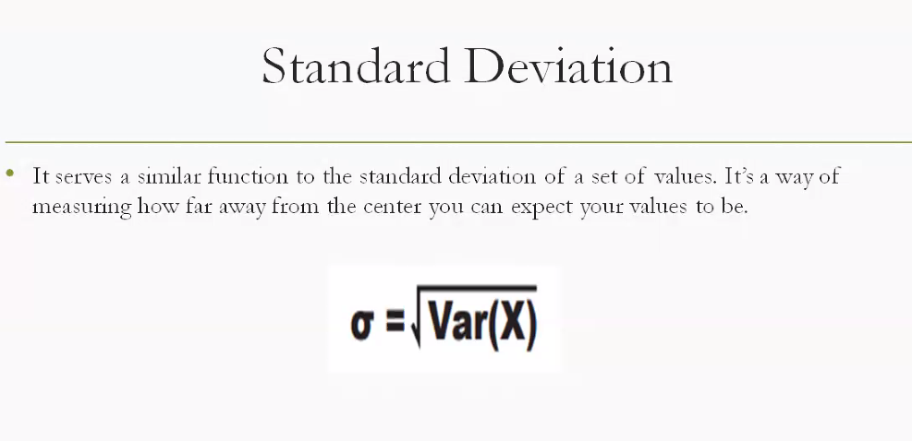

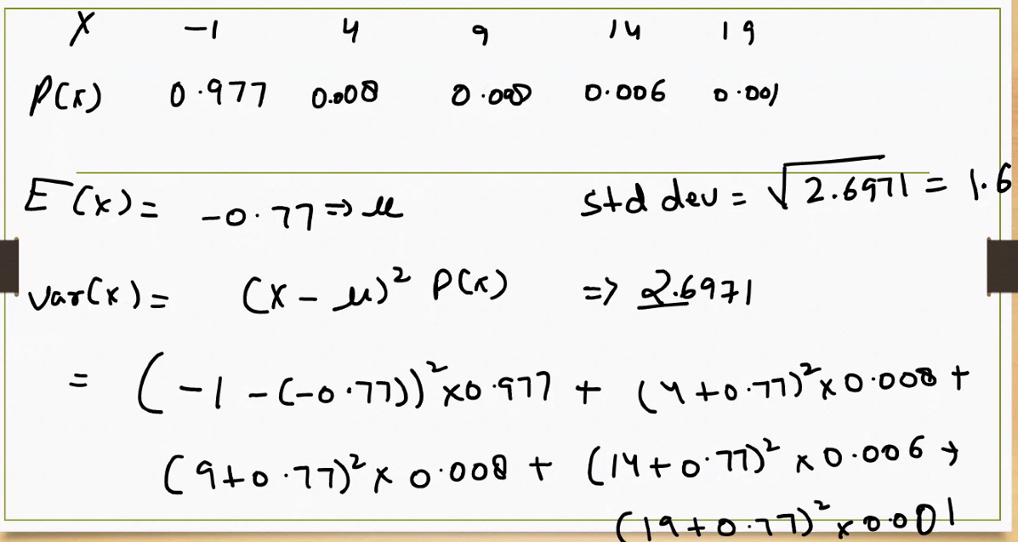
You're now working through variance for a discrete probability distribution, using actual values and probabilities from a slot machine game. Let’s break it down step by step.
📊 Given Distribution
Value $x$ | Probability $P(x)$
−1 | 0.977
4 | 0.008
9 | 0.008
14 | 0.006
19 | 0.001
These represent net gains from the game (after subtracting the $1 cost to play).
🧮 Step 1: Expected Value (Mean)
Already calculated as:
$$μ=E(X)=-0.77$$
This means that on average, a player loses 77 cents per play.
🧮 Step 2: Variance Formula
$$\text{Var}(X)=∑(x-μ)^{2}⋅P(x)$$
You compute the squared deviation from the mean for each value, multiply by its probability, and sum them all.
🧠 Step-by-Step Breakdown
Let’s compute each term:
- $(-1-(-0.77))^{2}⋅0.977=(-0.23)^{2}⋅0.977=0.0529⋅0.977≈0.0517$
- $(4-(-0.77))^{2}⋅0.008=(4.77)^{2}⋅0.008≈22.7529⋅0.008≈0.182$
- $(9-(-0.77))^{2}⋅0.008=(9.77)^{2}⋅0.008≈95.4729⋅0.008≈0.764$
- $(14-(-0.77))^{2}⋅0.006=(14.77)^{2}⋅0.006≈218.0329⋅0.006≈1.308$
- $(19-(-0.77))^{2}⋅0.001=(19.77)^{2}⋅0.001≈390.0729⋅0.001≈0.390$
📉 Final Variance
$$\text{Var}(X)≈0.0517+0.182+0.764+1.308+0.390=2.6957$$
✅ So, the variance is approximately 2.70
📌 Interpretation
- This tells you how spread out the gains/losses are around the average loss of $0.77.
- A higher variance means more risk — outcomes vary widely.
- You can also compute standard deviation as:
$$σ=\sqrt{\text{Var}(X)}≈\sqrt{2.70}≈1.64$$

🎯 Expected Value: $E(X)=-0.77$
This means that on average, a player loses ₹0.77 per spin.
- It’s a long-run average: If someone plays 1,000 times, they can expect to lose about ₹770.
- Even though some spins may win ₹4, ₹9, ₹14, or ₹19, the high probability of losing (0.977) dominates.
- This negative expected value is how casinos profit — the game is designed so the house always wins over time.
📉 Variance: $\text{Var}(X)≈2.70$
Variance tells us how spread out the outcomes are around the mean.
- A variance of 2.70 means the outcomes fluctuate quite a bit from the average loss of ₹0.77.
- This reflects the occasional big wins (₹14 or ₹19), which are rare but cause large deviations.
- The standard deviation is $\sqrt{2.70}≈1.64$, meaning most outcomes fall within ₹1.64 of the average.
📊 What This Means for Players
Metric | Interpretation
Expected Value | You lose ₹0.77 per spin on average
Variance | Outcomes vary widely — some big wins, mostly losses
Risk Profile | High certainty of small loss, low chance of big gain
This game is low-reward, high-risk: most spins lose money, and the few wins aren’t enough to offset the losses over time.

Standard Deviation: Absolutely — let’s now enrich your interpretation by adding standard deviation, which complements the expected value and variance beautifully.
📊 Recap of Key Metrics
Metric | Value | Interpretation
Expected Value | −₹0.77 | Average loss per spin
Variance | ≈ 2.70 | Spread of outcomes around the mean
Standard Deviation | $$\sqrt{2.70}≈1.64$$ | Typical deviation from the average
🧠 What Standard Deviation Tells You
- Standard deviation is the square root of variance. It gives a more intuitive sense of how much outcomes typically differ from the average.
- In your case, the average loss is ₹0.77, but the standard deviation is ₹1.64 — meaning:
  - Most outcomes fall within ₹1.64 of the mean.
  - So, typical results range from about −₹2.41 to ₹0.87.
- This reflects the fact that while most spins lose ₹1, there are occasional wins (₹4, ₹9, ₹14, ₹19) that pull the distribution outward.
🎯 Full Interpretation
- The game has a negative expected value (−₹0.77), so players lose money on average.
- The variance (2.70) shows that outcomes are not tightly clustered — there’s a wide spread due to rare but high payouts.
- The standard deviation (₹1.64) quantifies that spread in rupees, helping you understand the risk: even though most spins lose ₹1, some can win big, making the game feel exciting despite the long-term loss.

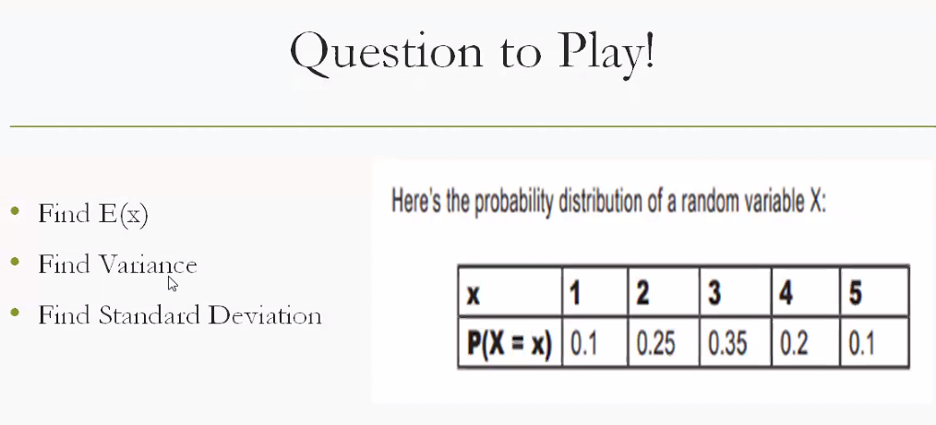
  - Bayes theorm assignment
  - Statistics : Which player is more consistent
  - Python assignment

